American Computer Science League
2004 - 2005

Contest #4

Intermediate Division

ACSL TREES

PROBLEM: Given a list of letters, construct a binary search tree. Once the tree is constructed find its depth and the number of leaf nodes. The depth of the tree is defined as the number of node levels below the root node. A leaf node is a node with no children.

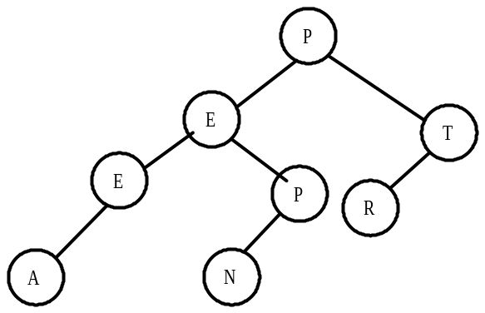

As an example, given the letters PETERPAN, the above binary search tree would be constructed. The depth of the tree is 3. P is the root node. It has a depth of 0. The E and T have a depth of 1. E, P and R have a depth of 2. A and N have a depth of 3. There are 3 leaf nodes: A, N and R.

INPUT: There will be 5 lines of input. Each line will consist of a string containing upper case letters.

OUTPUT: For each input line, print, in this order, the depth of the binary search tree formed and the number of leaf nodes.

SAMPLE INPUT SAMPLE OUTPUT

1. PETERPAN 1. 3, 3
2. EMMAUS 2. 3, 3
3. ACSL 3. 3, 1

American Computer Science League
2004 - 2005

Contest #4

Intermediate Division

ACSL TREES

TEST DATA

TEST INPUT TEST OUTPUT

1. ALLENTOWN 1. 4, 4
2. BOOKCASE 2. 5, 3
3. SCIENCELEAGUE 3. 6, 5
4. HEXADECIMAL 4. 4, 4
5. ADMINISTRATION 5. 6, 5

